|  |
| --- |
| Thanks for committing to Google Cloud learning. Make sure to claim your first month free on Google Cloud Skills Boost before May 31, 2022, 11:59 PM PDT, to complete the Data Engineer learning path. |

|  |
| --- |
| **Claim 30 days free access on Google Cloud Skills Boost** To begin, click ‘Start Learning’ by May 31, 2022 and your unique access code will be automatically applied. If this doesn't happen when you click ‘Start Learning’, simply copy your unique access code below and apply it when prompted. |

|  |
| --- |
| **Your unique access code: 1m-learningpath-268::sBmBAPQYb6SQ5urPb4NKsQ**(Expires May 31, 2022, 11:59 PM PDT) |

|  |
| --- |
| **To enjoy free access to the Data Engineer learning path, you must start by completing the first lab**, which will unlock your 30 days free. If you’re new to Google Cloud Skills Boost, you will need to create an account and complete the lab first to obtain your free access.  <https://go.cloudplatformonline.com/dc/X2R7oDDwEhxR9sYIShA9hKnI_5jo53oLS_i7EPFBQAVQK-rIGAFXq0-GPNUjRjikwo5EgQwzTRxrYQYA4qZGQtc3KtKLR5Wuy6iwQBEmHf5ErjEmU-wNv6ii85UWXUU1pBw01ecKz_nfEmm8PdrdlatBI0tkV7m-6C05MKdQbcjhrqjUH6VrlfYbf2v42fPuudhdI4PWsup235_WgRIBkihJUDTKekpz39Um2PCyJ8qGeHZsbWVj6FXAToLfQAr2kRGCd9qQ7_OYp9dv42R70g==/ODA4LUdKVy0zMTQAAAGEKeA8ArO-ao1vR_DOIGKdTVkaE2IVn4tI5fIMQBb3-uhMp94N7MUj1iCNLDKjBPH4tjcSirk=> |

<https://www.cloudskillsboost.google/paths/16?qlcampaign=1m-learningpath-268%3A%3AsBmBAPQYb6SQ5urPb4NKsQ>

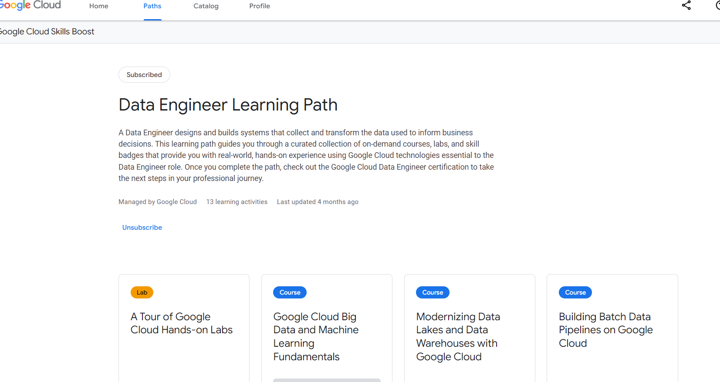

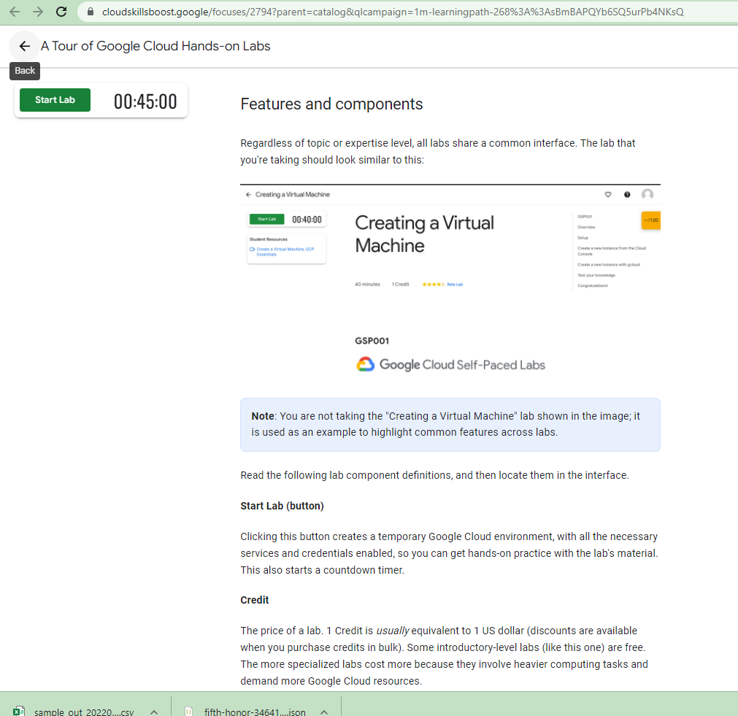

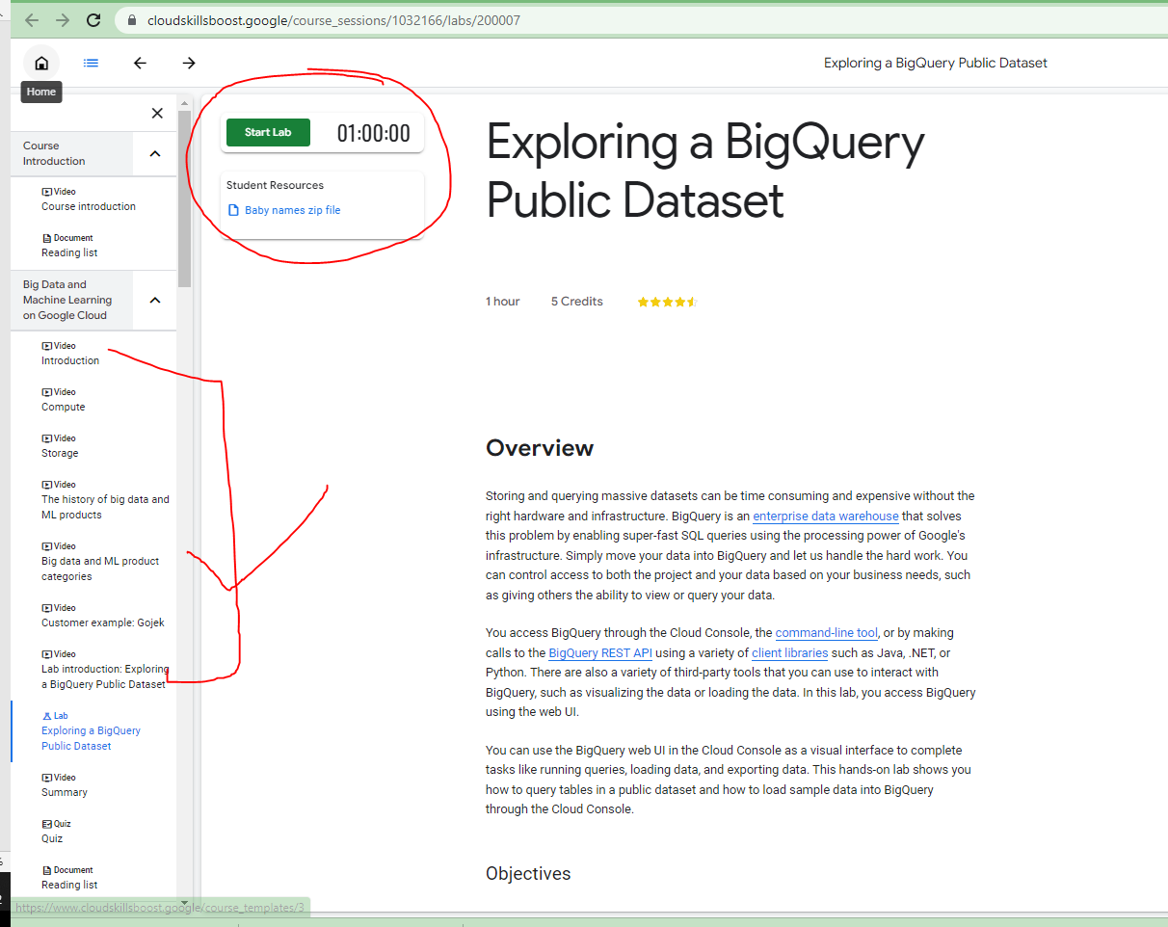

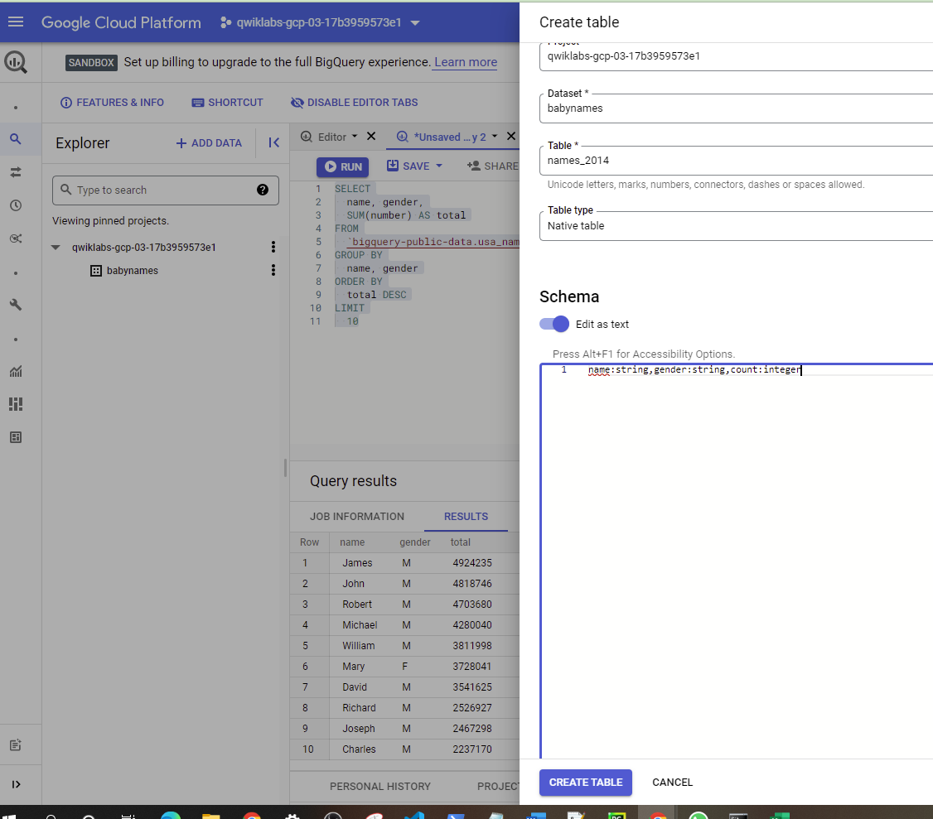

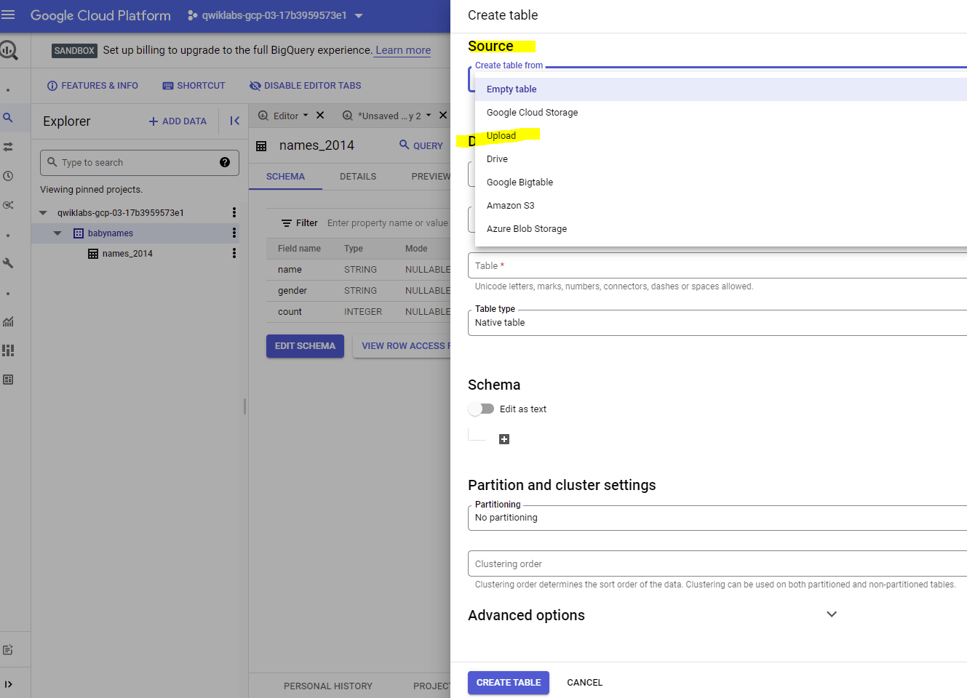

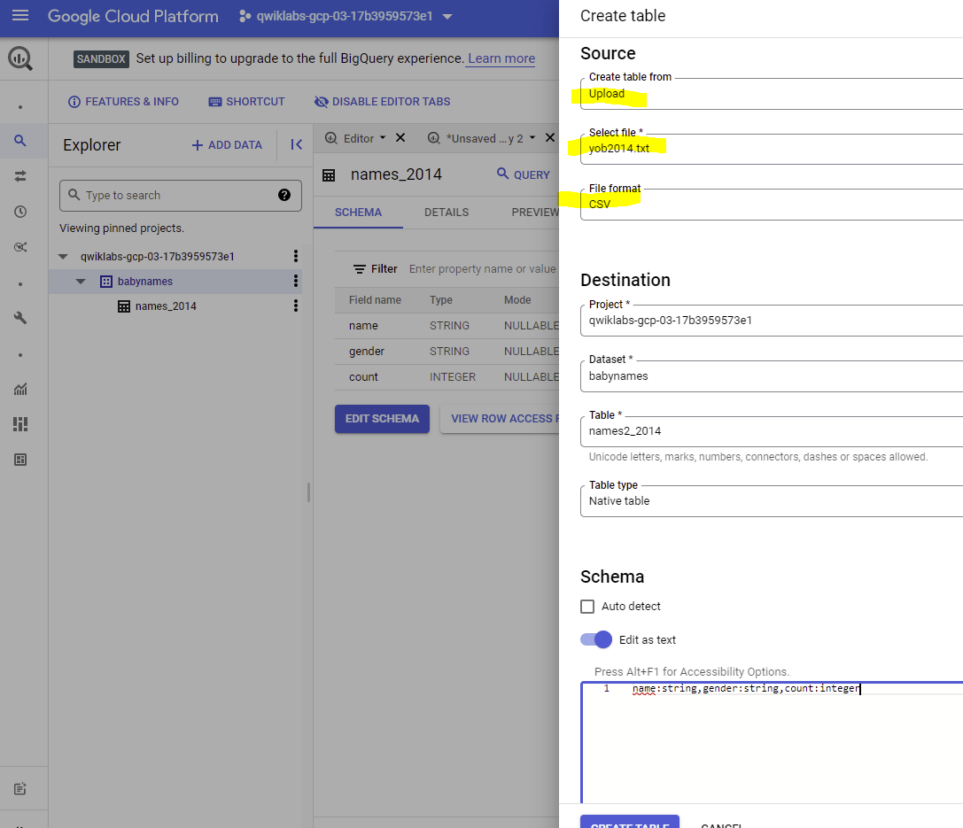

<https://www.youtube.com/watch?v=Wph83MRYbAM&list=PLlLpHNj8iPU9SULfEQiw2JrwEihiQEzY0&index=31&t=225s>

**Kubernetes Youtube vds 🡪**

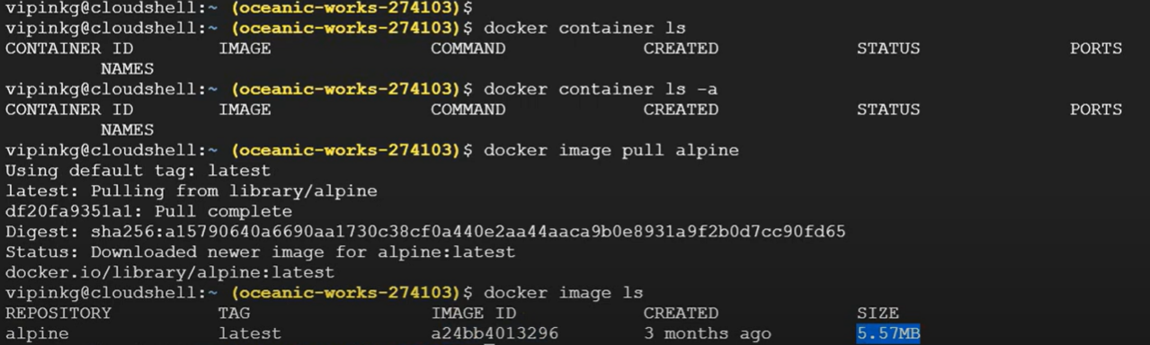

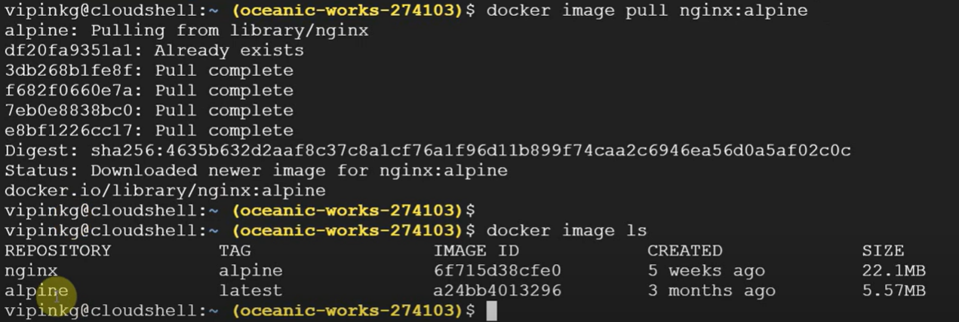

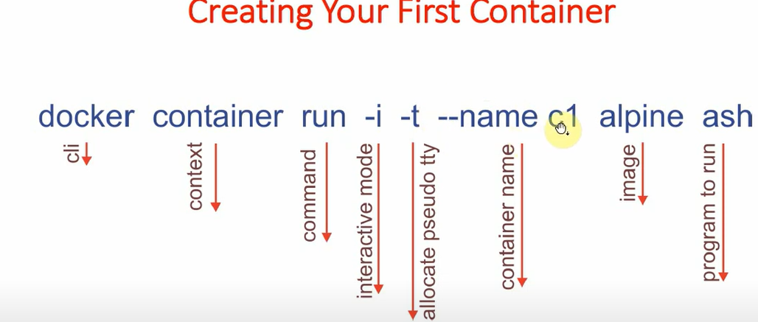

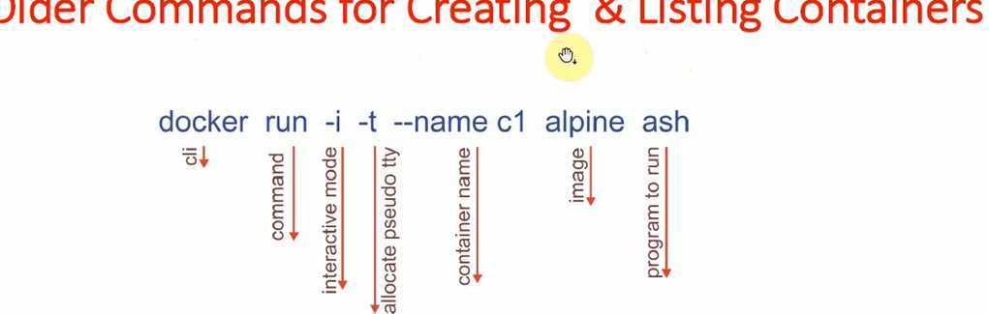

Why kubernets requird 🡪

For horizonal scalling ,need to add more nodes/pods /containers/VM

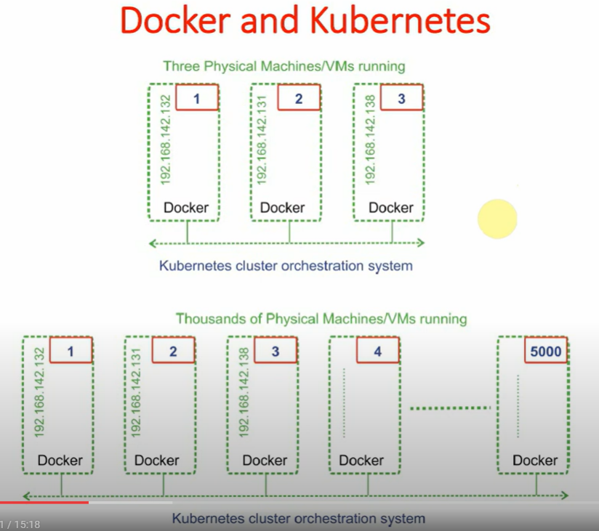

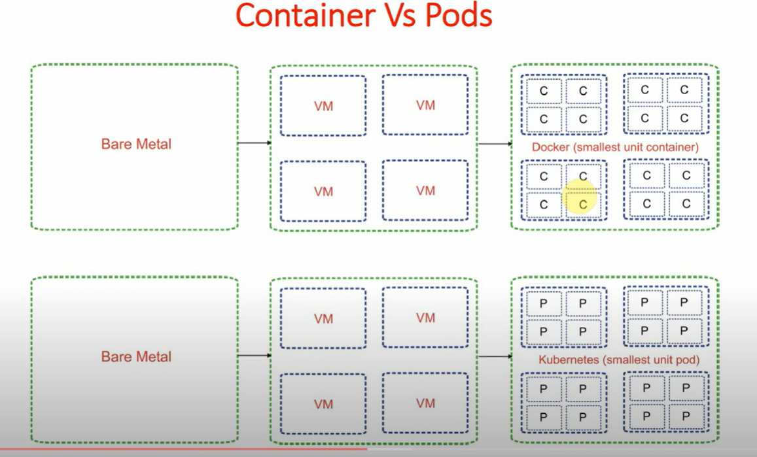

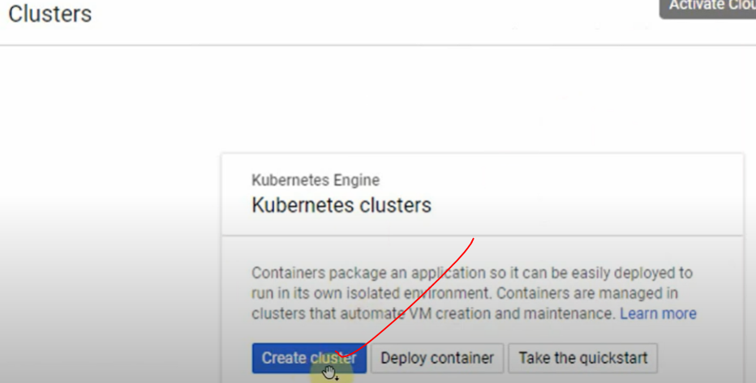

ONCE your cluster has been created then run below commands 🡪

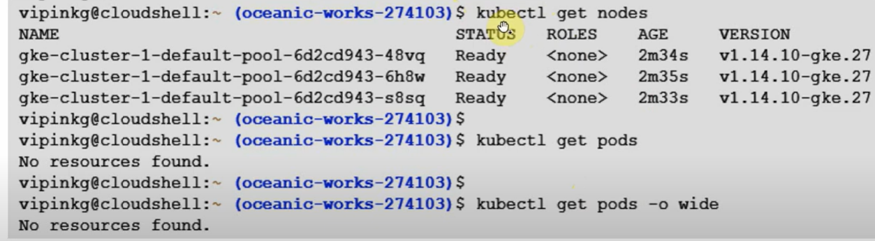

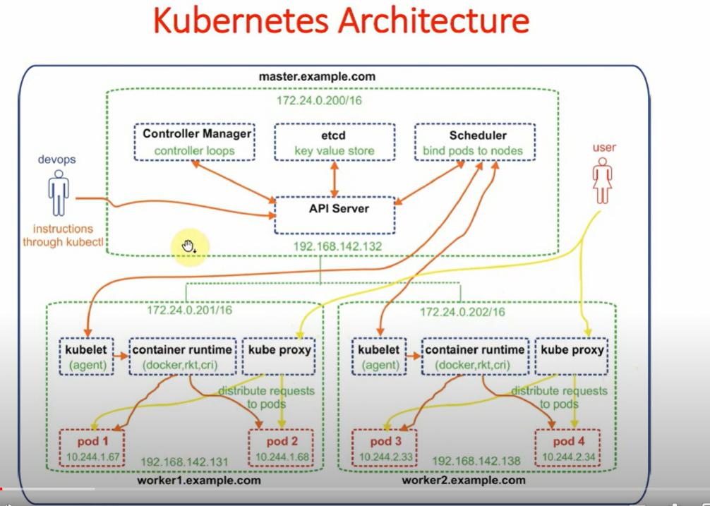

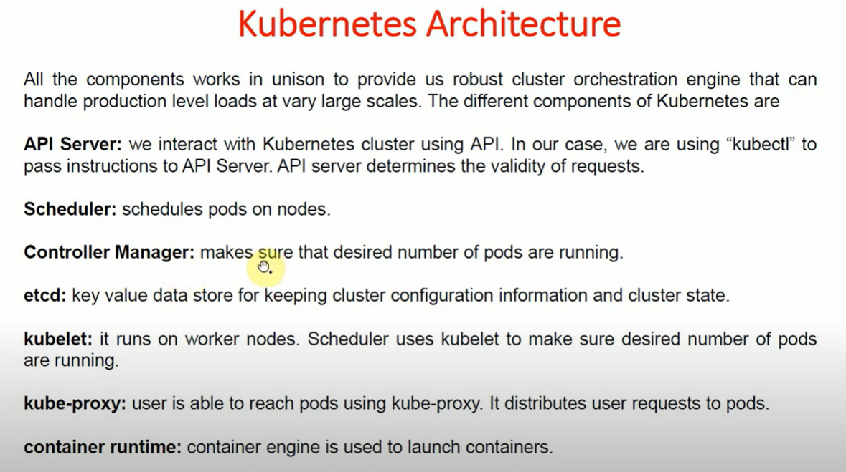

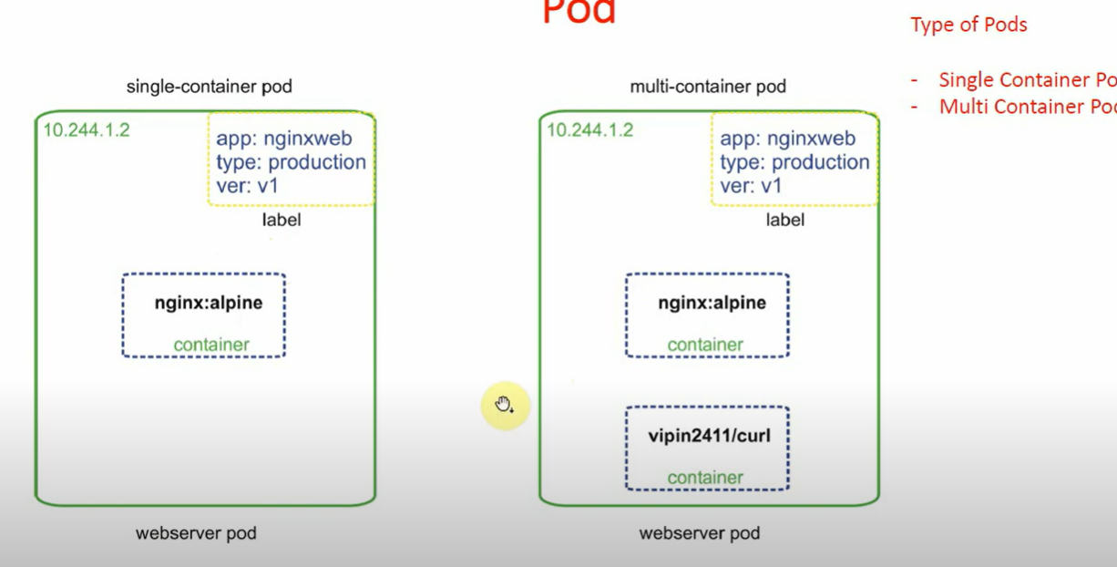

**If you want go with the Pod# webserver kubectl exec -it webserver – sh**

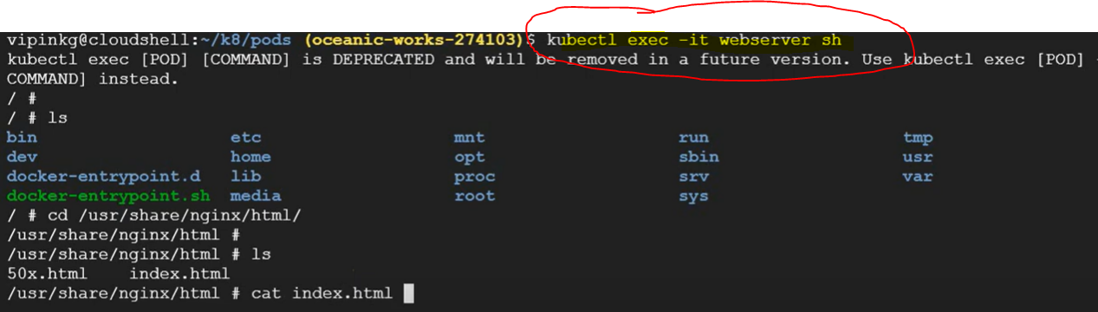

**We are in a container # WEB because we have only one container in a pod webserver .**

**Kubectl exec -it -c web webserver – sh**

If we have more than two one container in a pod then use above command

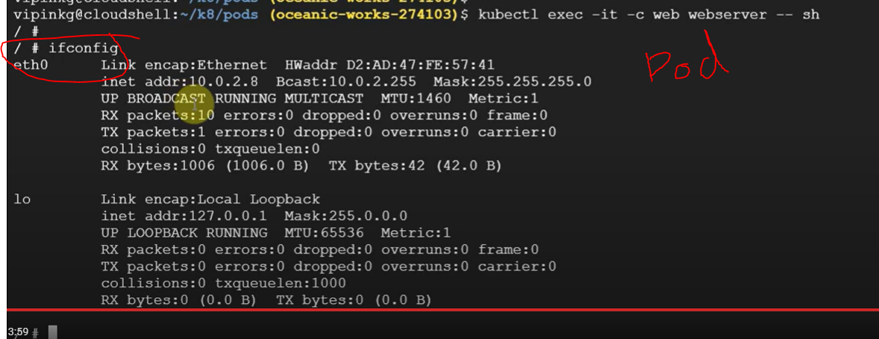

Ifconfig Or **ip a s**

**We can delete the pod wth using the same yaml file**



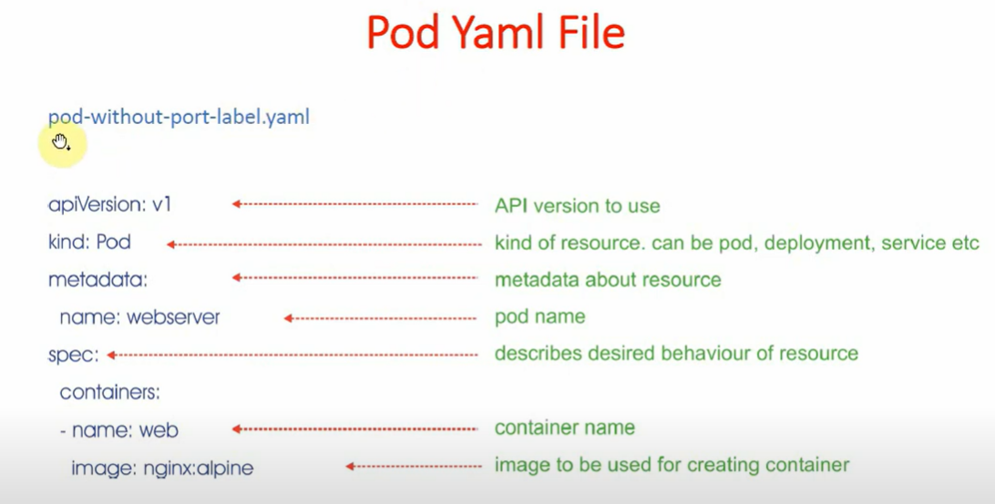

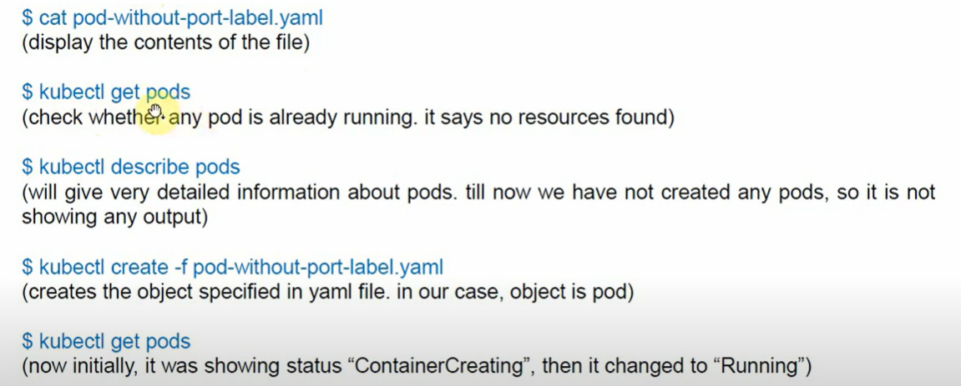

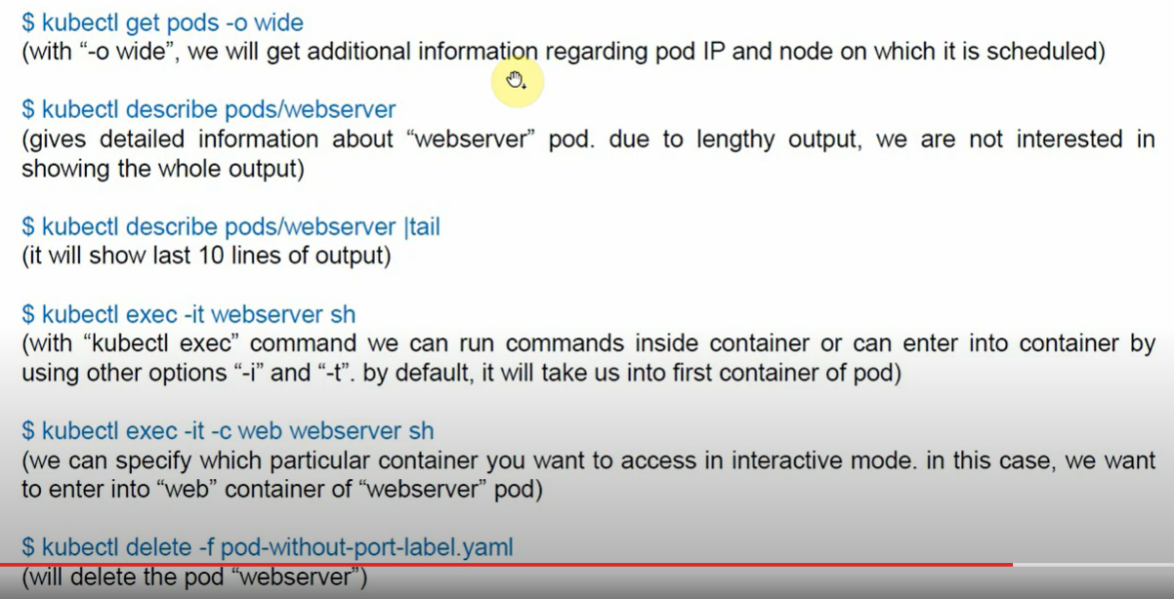

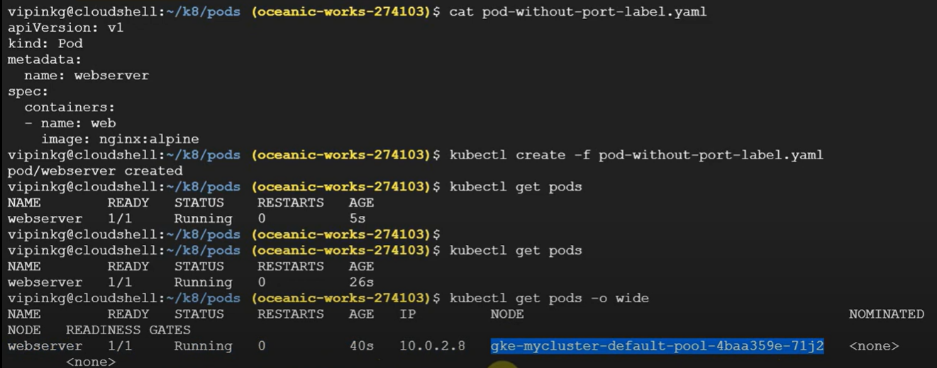



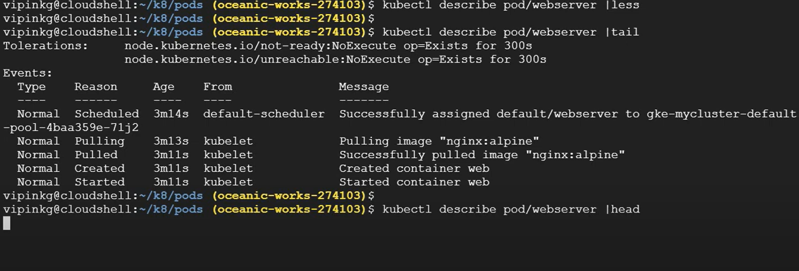

Two containers in a pod 🡪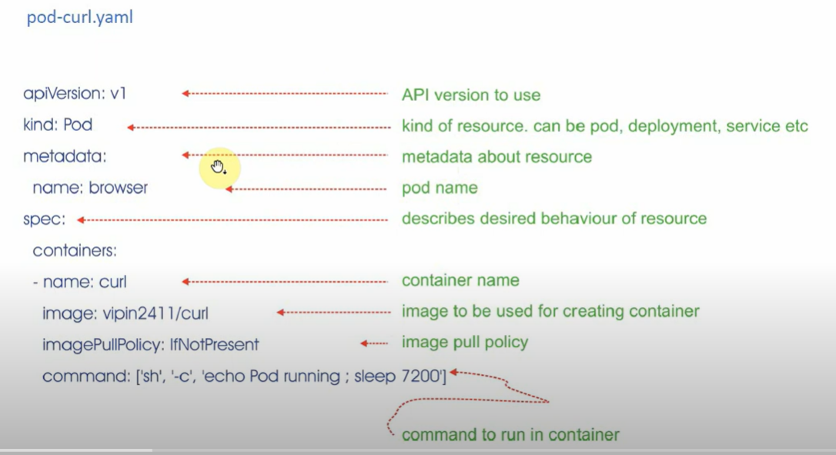

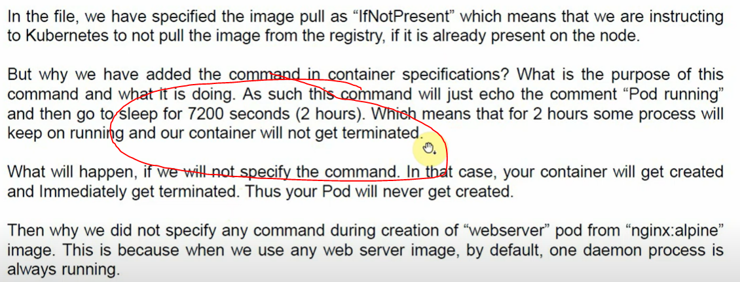

If we create any container in a pod , need to make sure any services / process should be running in a container , else the pod will terminate .

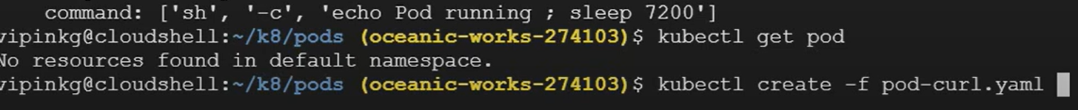

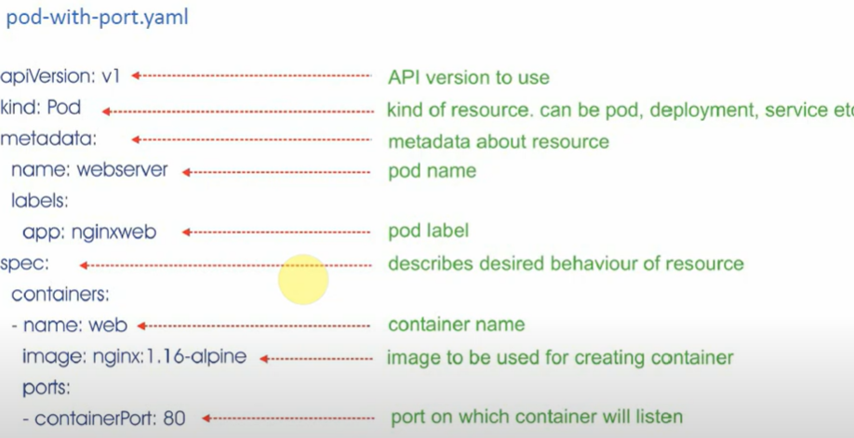



Created a another pod

And now we have two pods # webserver, browser

* **Pod Webserver : Container :web**
* **Pod browser: Container :Curl**

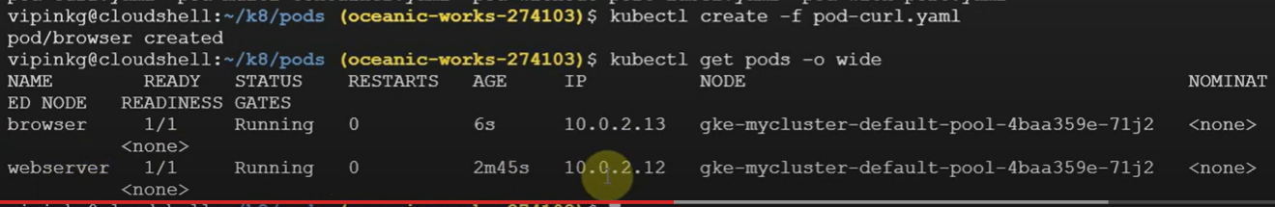



We can access a pod in another pod

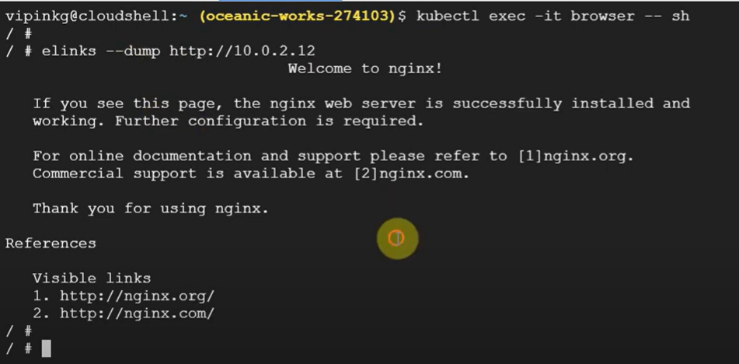

Need to get access a pod in a node

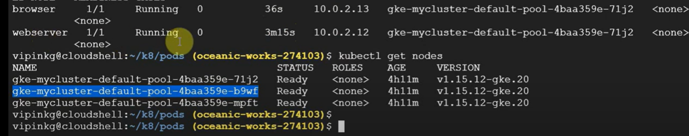

Node to Pod Communication🡪

Connect first Node 🡪

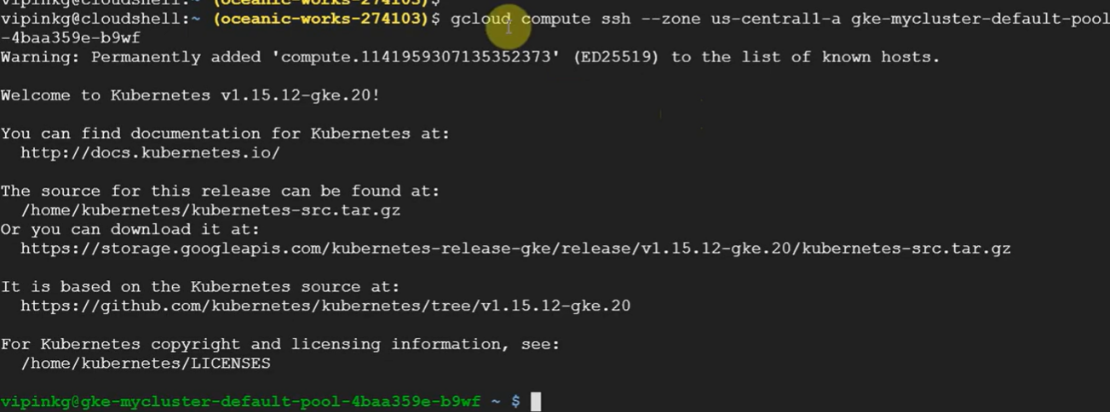

Every node/VM has docker running :

$ docker version |less

Ifconfig |less

Now creating a PODs





Pod ‘s ip 10.0.2.14

Now in node 🡪

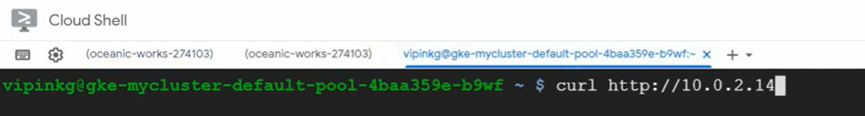

Accessing the pod

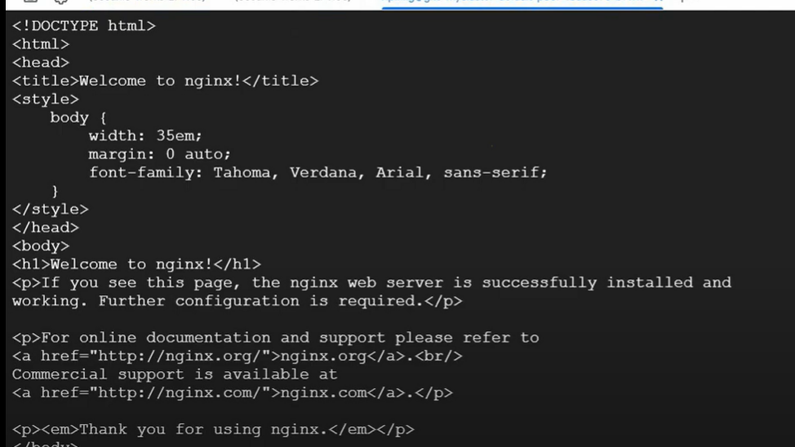

Multiport container 🡪

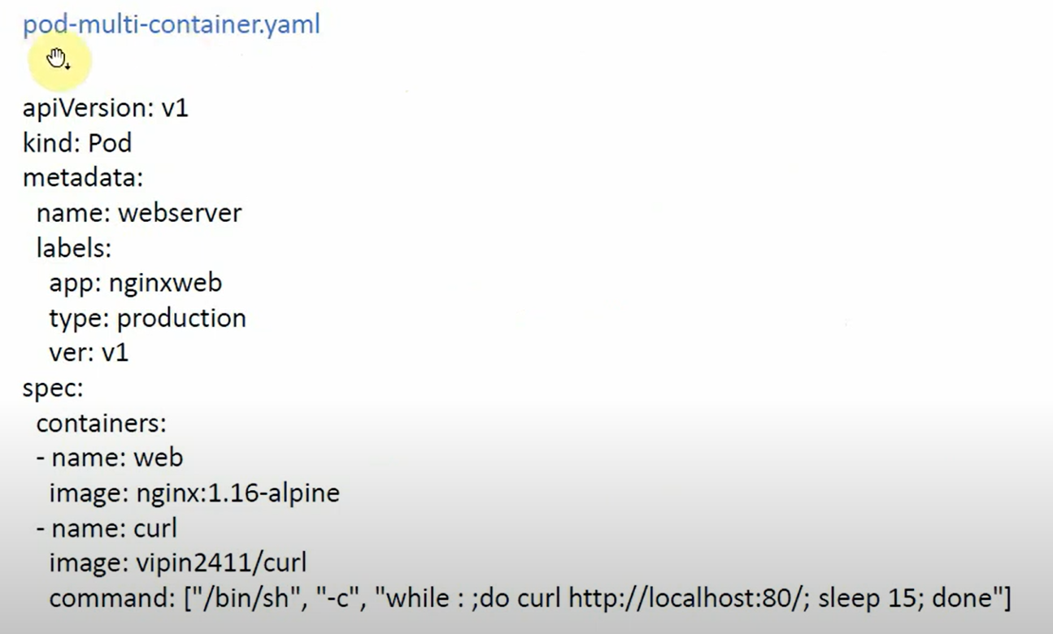



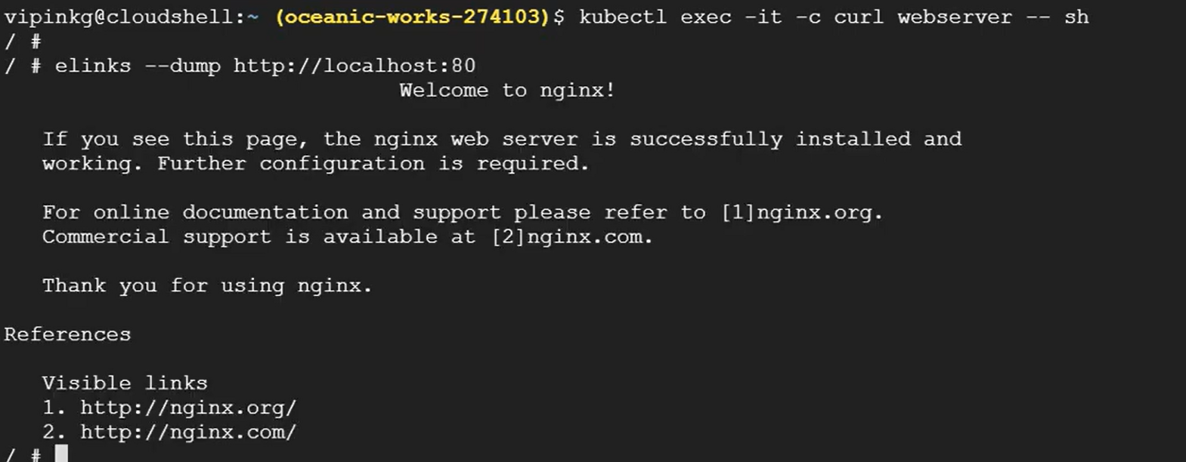

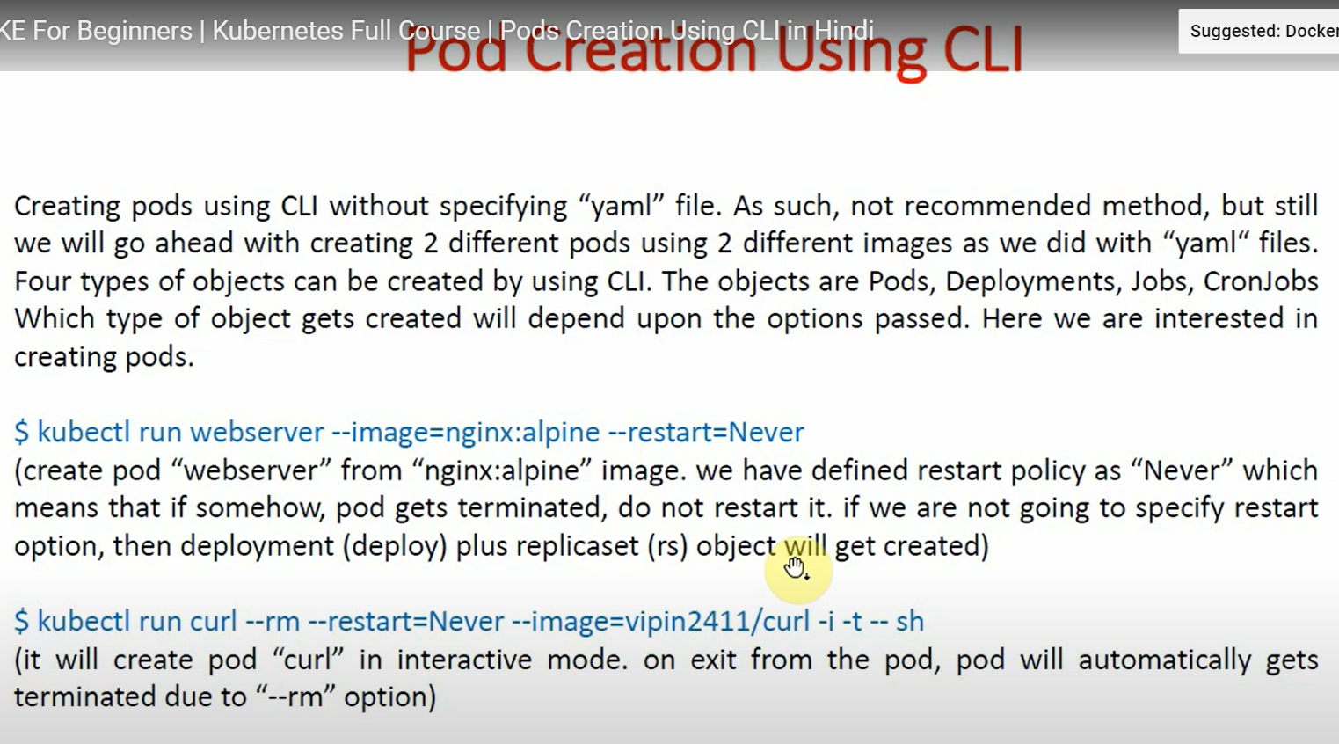

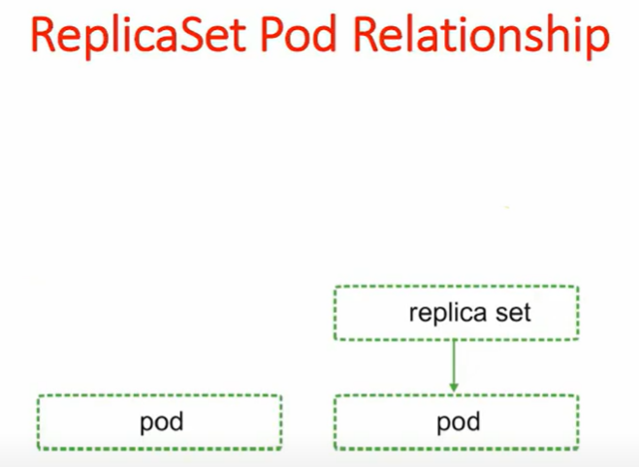

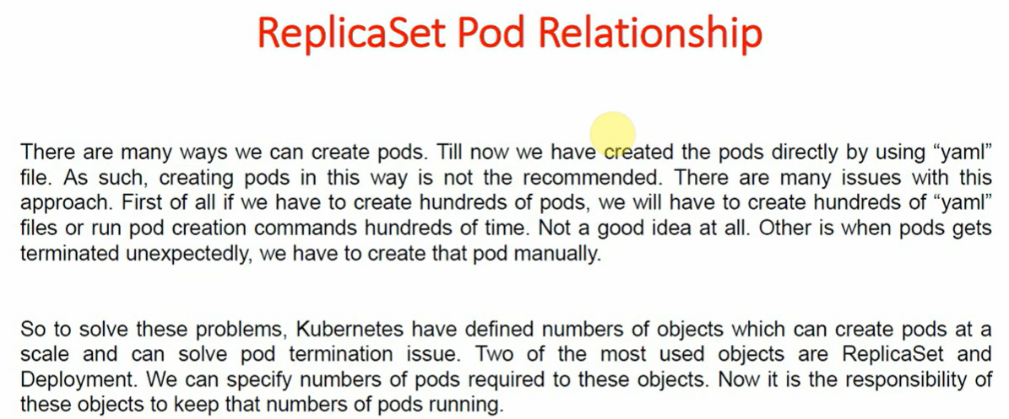

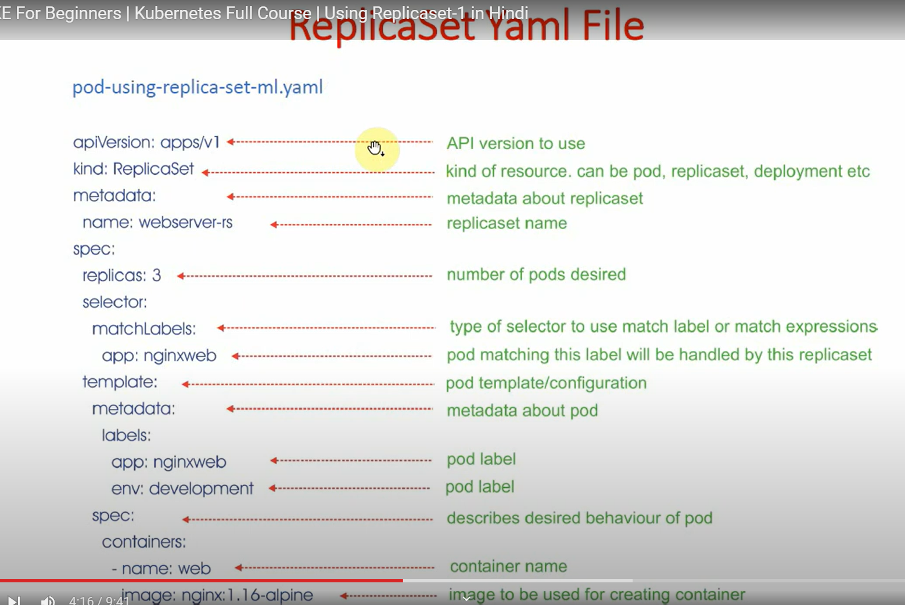

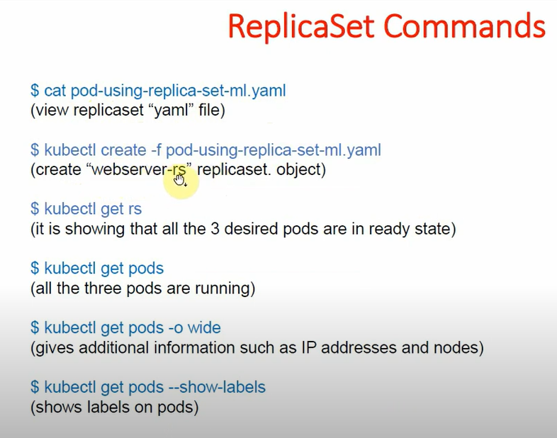

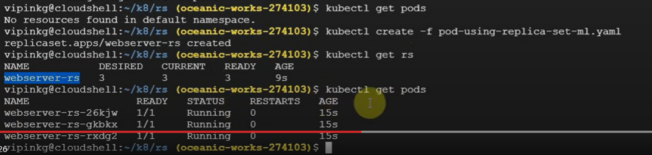

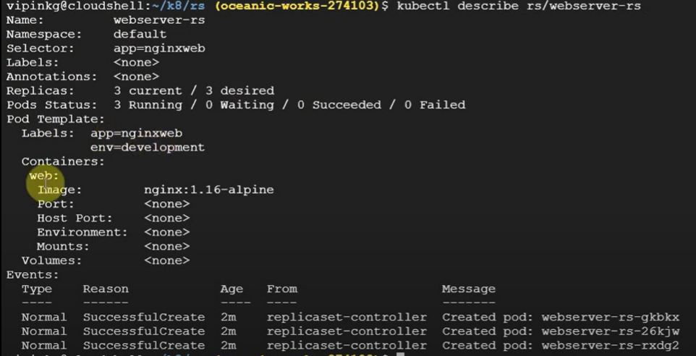

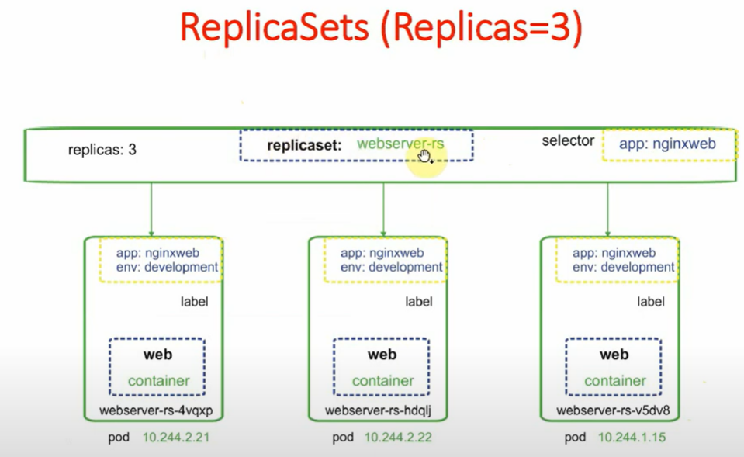

If you want to change setting in yaml file you should apply

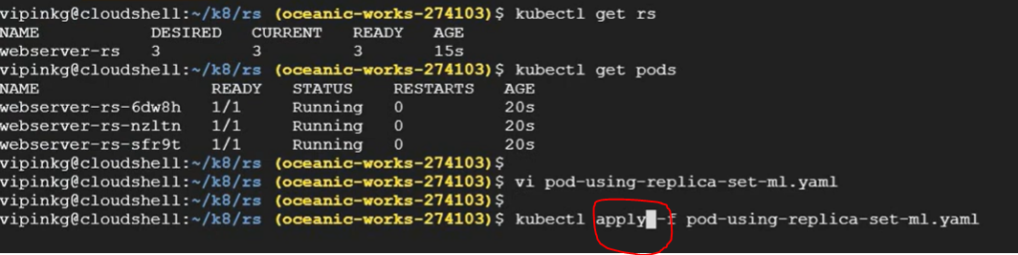



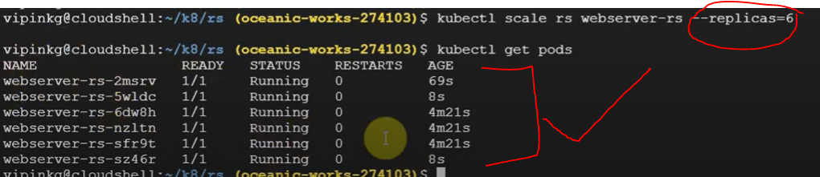

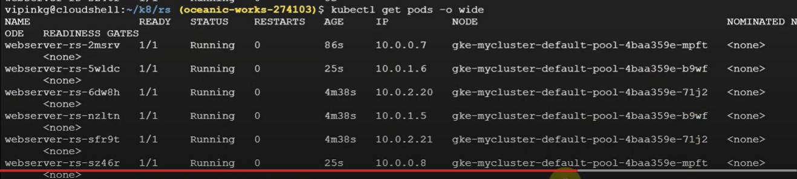

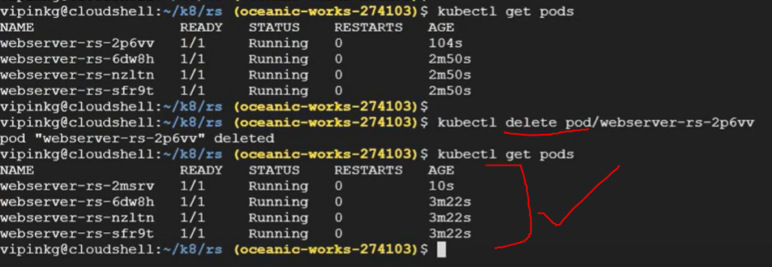

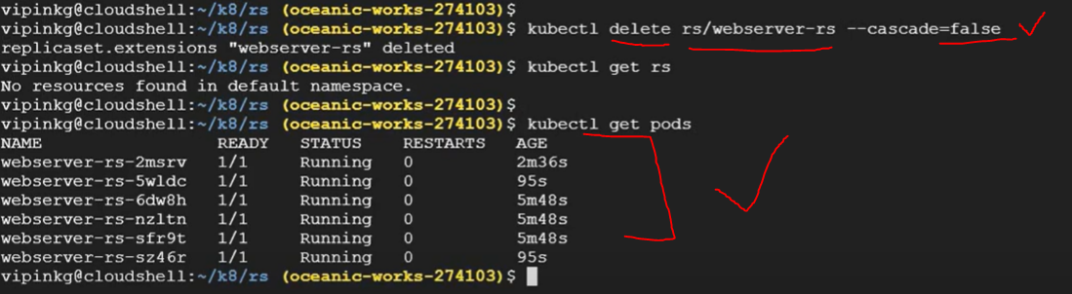

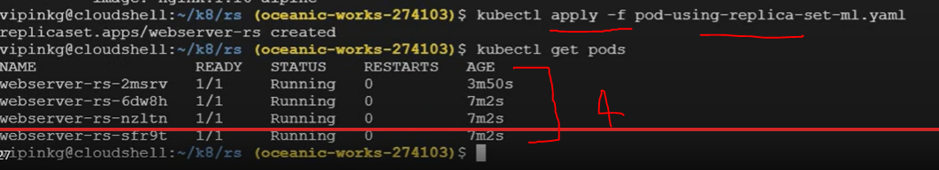

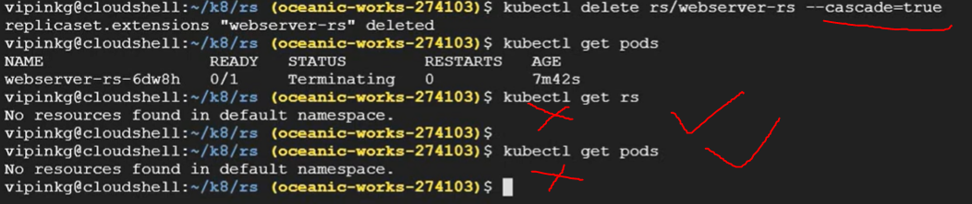

Deployement 🡪

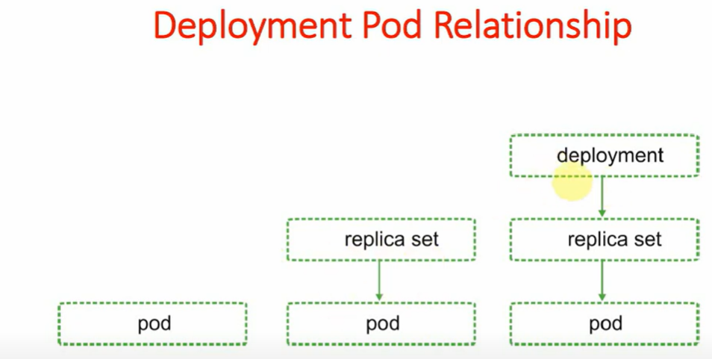

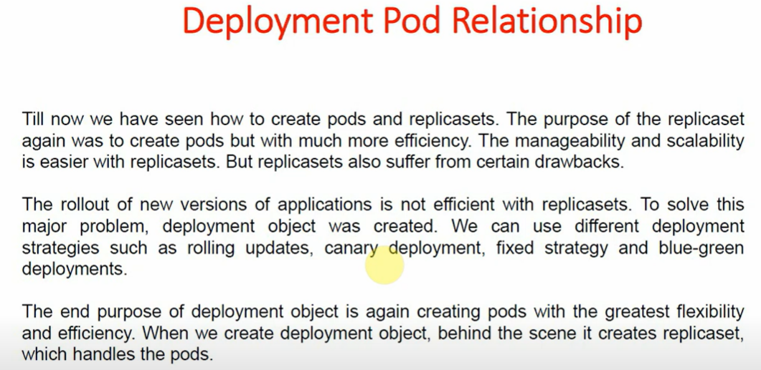

We can perform versioing whle running pods ..

We can update our code in running application don’t need to down application.

